**Separation of Dye Mixture Using Chromatography**

**Materials**

FD&C food dye mixtures, 1 ml Chromatography paper strips

Isopropyl alcohol solution, 2%, 60 ml Sodium Chloride solution, 2%, 60 ml

Toothpicks Spot Plate

Beakers, 250 ml Watch glasses, 2

**Safety Precautions**

Isopropyl alcohol is a moderate fire risk and is slightly toxic by ingestion or inhalation. Use proper exhaust ventilation to keep airborne concentrations low. The FD&C dyes are slightly hazardous by ingestion, inhalation, and eye or skin contact. Red No. 40 may be absorbed through the skin and Yellow No. 5 may be a skin sensitizer. All dyes are irritating to skin and eyes. Avoid contact with eyes, skin, and clothing. Wear chemical splash goggles, chemical resistant gloves, and a chemical resistant apron. Wash hands thoroughly with soap and water before leaving the laboratory. Please follow all laboratory safety guidelines.

**Procedure**

1. Select a piece of chromatography paper. Note: handle the paper by the edges so the analysis area is not accidentally compacted or contaminated.

2. Using a ruler and a pencil, draw a faint line 15 mm from the bottom of the paper across the width of the strip. This is the starting point for the sample.

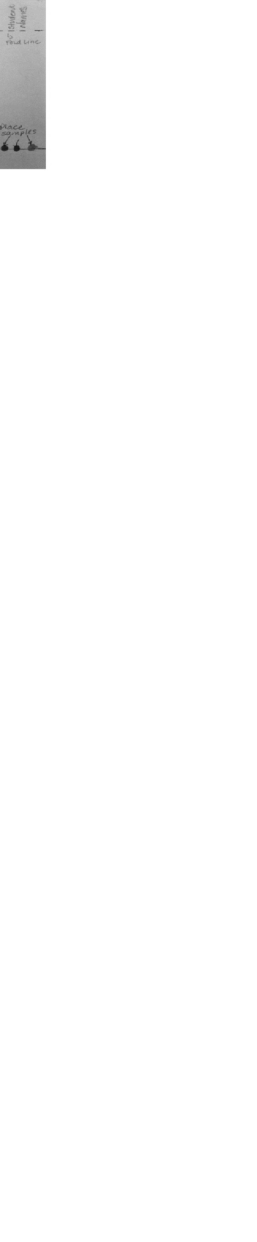

3. Using the same ruler, measure 20 mm from the top of the strip and fold across the width of the strip. This will allow the strip to hang on the lip of the beaker. Write your names and period above the fold.

4. Repeat steps 2 and 3 for a second paper strip.

5. READ BEFORE DOING: Using a clean toothpick, spot the chromatography strip by placing a toothpick into the red dye mixture solution and then touching the tip of the tooth pick gently onto the left side of the line 15 mm from the bottom. Allow the sample to dry. Repeat the procedure two to three more times. Note: This step is necessary to increase the concentration of the sample, but do not allow the size of the spot to increase. Spot the yellow dye in the center of the strip and the blue dye at the right side. DO NOT ALLOW THEM TO MIX.

6. Repeat step 5 for the second chromatography strip.

7. While the papers are drying note the beakers labelled alcohol and NaCl. Each beaker should have approximately 50 ml of liquid in it, covered by a watch glass.

8. Once the chromatography paper is dry, remove the watch glass from the top of the beaker. Carefully hang the chromatography strip into the beaker with the sample end down. Do not get any solvent on the upper portion of the strip. **The sample spots must remain above the level of the solvent**.

9. Carefully place the watch glass back on the top of the beaker. Allow the chromatogram to develop, at least 10 minutes. Record observations of the dye sample as the solvent travels up the paper and the chromatogram develops.

10. Repeat steps 10 and 11 using the other chromatography strip and beaker.

11. After the 10 minutes have elapsed, stop the run by removing the strip from the beaker.

12. With a pencil, lightly draw a line to mark the distance the solvent traveled. This is called the solvent front.

13. Measure the distance from the pencil line at the bottom of the strip to the solvent front. Record this distance in millimeters in an appropriate data table.

14. With a pencil, trace the shape of each dye band or spot to mark its location on the chromatography strip. This should be done immediately because the color and brightness of some spots may fade over time.

15. Measure and record the distance in millimeters that each dye band or spot traveled. Measure from the line at the bottom of the paper to the center of each band or spot.

16. Repeat steps 12-16 for the other chromatograms.

17. Test your unknown using the chromatography procedure to determine which dye(s) are present in the sample by comparing it to the known pattern of the FDC dyes.